Glemsford Parish Council
Notice of meeting to be held at Glemsford Village Hall
Tuesday 9th December 2025 @ 7.00pm
Issued by Mrs Julia Howard,
3rd December 2025
AGENDA
All members of the Council are hereby summonsed to attend the meeting for the purpose of considering and resolving upon the business to be transacted as set out hereunder
25/144 Parish Announcements
25/145 Apologies for absence
25/146 Declarations of interest / dispensation requests
25/147 To adopt the minutes of the last Council meeting
25/148 To receive reports: County Councillor’s report (Mr Kemp) (none this month)
District Councillor’s report (Mr M Holt)
District Councillor’s report (Mr S Plumb)
25/149 Public Question Time
25/150 Financial Matters
Item 1. To note receipts and approve upcoming payments
Item 2. Budget Setting for 26/27 and precept request
25/151 Planning
New Applications –
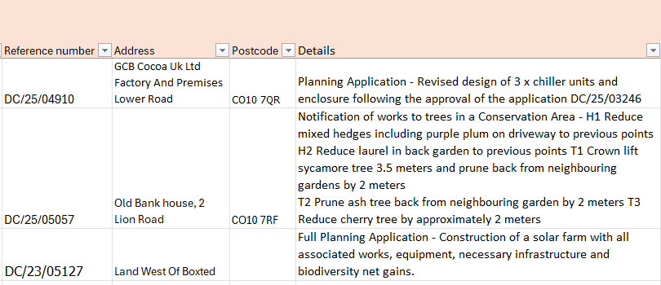
Decisions
25/152 Neighbourhood Plan
25/141 Reports from Working Group leads where requested
1. Finance (Lesli)
2. Village Hall (Debbie)
3. Planning / Neighbourhood Plan (Wendy)
4. Public Rights of Way / Highways (Bill)
5. Play Parks (Adrian)
6. Community Engagement & Events – (Debbie /Wendy) Parish Council Christmas event
25/142 Correspondence to report
25/143 Date of next Parish Council meeting: 13th January

