Members of the Council are hereby summoned to attend the
GLEMSFORD PARISH COUNCIL Meeting @ Glemsford Village Hall
ON Tuesday 9th February 2026 at 7pm for the purpose of transacting the following business.
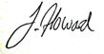
Members of the press and public are welcome to attend.
4th January 2026
Julia Howard, Clerk to Glemsford Parish Council
A G E N D A

26/012 Parish Announcements
26/013 Apologies for absence
26/014 Declarations of Interest /dispensation requests
To declare any Disclosable Pecuniary or non-Pecuniary Interest relating to items on the agenda
26/015 To adopt the minutes of the last Council meeting
26/016 To receive reports: County Councillor’s report (Mr Kemp) (none this month)
District Councillor’s report (Mr M Holt)
District Councillor’s report (Mr S Plumb)
26/017 Public Question Time
Public Participation Session with respect to items on the agenda and other matters of mutual interest. Please note: The maximum time allowed for this item is 15 minutes but may be extended at the discretion of the Chairman
26/018 Financial Matters To note and Decision
Item 1. To note receipts and approve upcoming payments
Item 2. Budget status update
26/019 Admin
Item 1. Confirmation of internal auditor
Item 2. Councillor Training
Item 3. Internal Audit review of actions
Item 4. Policies for review
Item 5.Internal control statement

26/019 Planning
Applications –
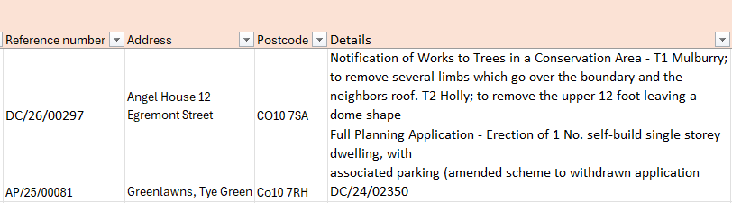

And DC/26/00441 - 66 Tye Green, CO10 7RG. Application of works to trees in a Conservation Area - G1 Reduce row of conifers back to previous pruning points approximately 4 meters to maintain the shape of the
boundary hedge

Decisions
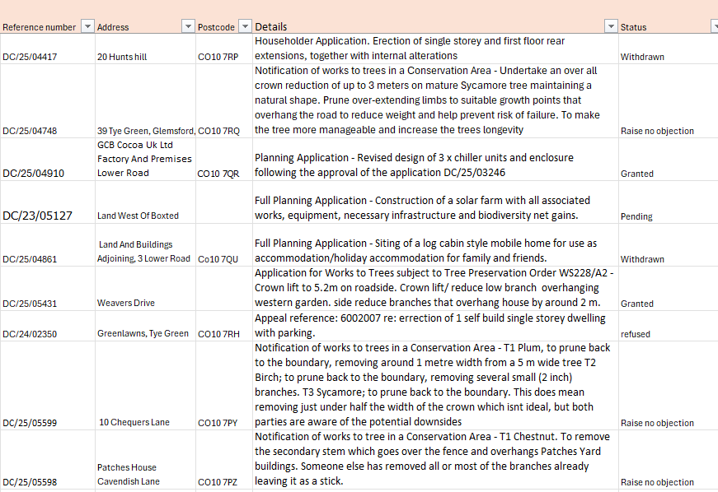

26/020 Reports from Working Group Leads, where requested
- Village Hall 2. Allotments 3. Events 4. Cemeteries
26/021 Correspondence to report
26/022 Meeting Close & Date of Next meeting

