Members of the Council are hereby summoned to attend the
GLEMSFORD PARISH COUNCIL Meeting @ Glemsford Village Hall
ON Tuesday 13th January 2026 at 7pm for the purpose of transacting the following business.
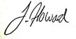
Members of the press and public are welcome to attend.
6th January 2026
Julia Howard, Clerk to Glemsford Parish Council
A G E N D A

26/001 Parish Announcements
26/002 Apologies for absence
26/003 Declarations of Interest /dispensation requests
To declare any Disclosable Pecuniary or non-Pecuniary Interest relating to items on the agenda
26/004 To adopt the minutes of the last Council meeting
26/005 To receive reports: County Councillor’s report (Mr Kemp) (none this month)
District Councillor’s report (Mr M Holt)
District Councillor’s report (Mr S Plumb)
26/006 Public Question Time
Public Participation Session with respect to items on the agenda and other matters of mutual interest. Please note: The maximum time allowed for this item is 15 minutes but may be extended at the discretion of the Chairman
26/007 Financial Matters To note and Decision
Item 1. To note receipts and approve upcoming payments
Item 2. Precept request
26/008 Planning
Applications –
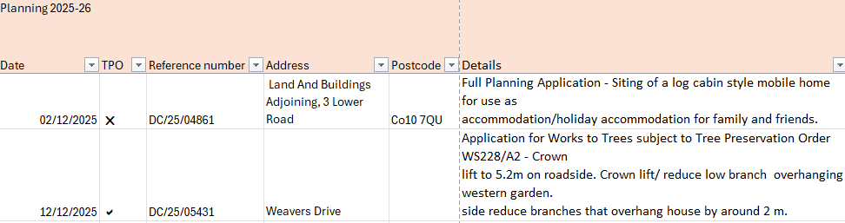

Decisions
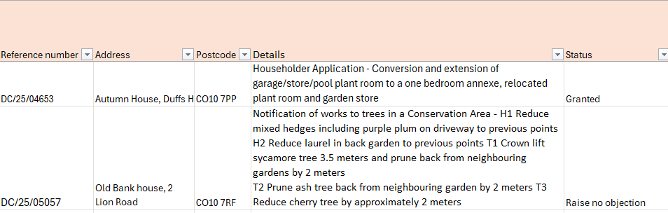

26/009 Reports from Working Group Leads, where requested
- Village Hall 2. Events 3. Highways
26/010 Correspondence to report
26/011 Meeting Close & Date of Next meeting

