Members of the Council are hereby summoned to attend the
GLEMSFORD PARISH COUNCIL Meeting @ Glemsford Village Hall
ON Tuesday 10th March 2026 at 7pm for the purpose of transacting the following business.
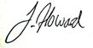
Members of the press and public are welcome to attend.
4th March 2026
Julia Howard, Clerk to Glemsford Parish Council
A G E N D A

26/023 Parish Announcements
26/024 Apologies for absence
26/025 Declarations of Interest /dispensation requests
To declare any Disclosable Pecuniary or non-Pecuniary Interest relating to items on the agenda
26/026 To adopt the minutes of the last Council meeting
26/027 To receive reports: County Councillor’s report (Mr Kemp) (none this month)
District Councillor’s report (Mr M Holt)
District Councillor’s report (Mr S Plumb)
26/028 Public Question Time
Public Participation Session with respect to items on the agenda and other matters of mutual interest. Please note: The maximum time allowed for this item is 15 minutes but may be extended at the discretion of the Chairman
26/029 Financial Matters To note and Decision
Item 1. To note receipts and approve upcoming payments
Item 2. Budget status update
Item 3. To agree to appoint ROSPA for playpark inspections
26/030 Admin
Item 1. Internal Audit review of actions
Item 2. New Investment Policy and New IT Policy for review and Internal control statement
26/031 Planning
Applications –
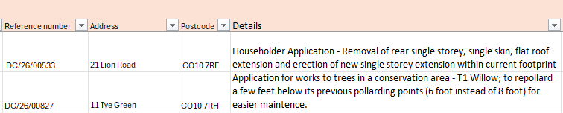

Decisions
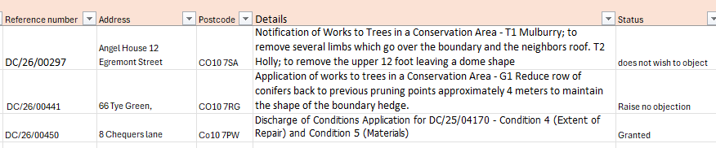

26/032 Neighbourhood plan update – to provide an update where possible
26/033 Village Hall – Old Library refurbishment - to agree to receive a grant and apply additional funds from neighbourhood CIL or PC funds to complete the works.
26/034 Increase in Cemetery Fees – to agree to a small increase in the cemetery charges
26/035 Reports from Working Group Leads, where requested
26/036 Correspondence to report
26/037 Meeting Close & Date of Next meeting

