Glemsford Parish Council
Notice of meeting to be held at Glemsford Village Hall
Tuesday 11th November 2025 @ 7.00pm
Issued by Mrs Julia Howard,
5th November 2025
AGENDA
All members of the Council are hereby summonsed to attend the meeting for the purpose of considering and resolving upon the business to be transacted as set out hereunder

25/130 Parish Announcements
25/131 Apologies for absence
25/132 Declarations of interest / dispensation requests
25/133 To adopt the minutes of the last Council meeting
25/134 To receive reports: County Councillor’s report (Mr Kemp) (none this month)
District Councillor’s report (Mr M Holt)
District Councillor’s report (Mr S Plumb)
25/135 Public Question Time
25/136 Financial Matters
Item 1. To note receipts and approve upcoming payments
Item 2. Budget update and Bank reconciliation
25/137 Planning
New Applications –
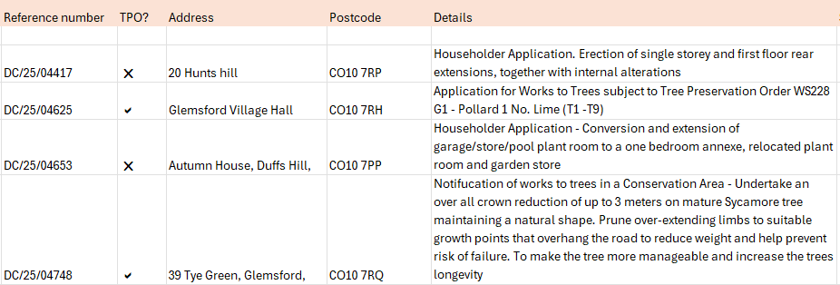Decisions
Approval: Discharge of Conditions Application for DC/22/04613 - Condition 6 (Fenestration) Location: 17 Chequers Lane, Glemsford, Sudbury, Suffolk CO10 7PW

Approval: Discharge of Conditions Application for DC/22/04532 - Condition 10 (Air Source Heat Pump), 11 (External lighting), 13 (Electric Vehicle Charging), 14 (Cycle Storage) and 17 (Biodiversity Enhancement Strategy) Location: New Street Farm, New Street, Glemsford, Sudbury Suffolk CO10 7PY

No Objection: DC/25/04312 TPO Notification of Works to Trees in a Conservation Area -T1 Apple, T2 Pear To fell to ground level. 11 Churchgate, Glemsford, Sudbury, Suffolk CO10 7QE

25/138 Neighbourhood Plan
25/139 Decision regarding the bin at Hunts Hill stores
25/140 Marking of spaces in the village hall car park
25/141 Reports from Working Group leads
1. Finance (Lesli)
2. Personnel (Lesli)
Christmas closure of the Village Hall / annual leave
3. Village Hall (Debbie)
4. Cemetery (Paul)
5. Planning / Neighbourhood Plan (Wendy)
6. Public Rights of Way / Highways (Bill)
7. Greening Glemsford (Lesli)
8. Play Parks (Adrian)
9. Allotments (Alison)
10. Community Engagement & Events – (Debbie /Wendy) Remembrance Day and Christmas event

25/142 Correspondence to report
25/143 Date of next Parish Council meeting: 9th December

