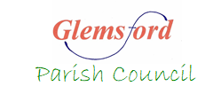

**Glemsford Annual Parish Meeting**

**(Followed by Monthly Parish Council Meeting under separate agenda)**

**You are warmly invited to attend this parish meeting**

**to discuss parish affairs**

**Reports will be made by Village Organisations**

**To be held on Tuesday 8th April at 6.45pm**

**At the Village Hall (main hall)**

**AGENDA**

1. **Chairman’s welcome**
2. **Apologies for absence**
3. **Minutes**
4. **Parish Council report**
5. **Reports from County and District Councillors**
6. **Reports from village organisations**

Julia Howard

Clerk to Glemsford Parish Council 18th March 2025