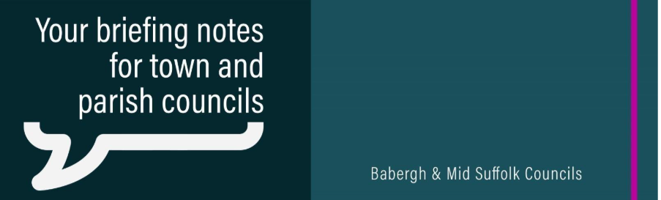
Council agrees ‘financially responsible’ budget to protect services and promises to communities
Babergh District Council has agreed a budget which protects vital services and unlocks funding to deliver promised community projects.

Pylons project would ‘devastate’ special Suffolk landscapes, councils warn
National Grid’s plan for more pylons in the Suffolk countryside should be halted, leading councillors from Babergh and Mid Suffolk District Councils have told a public hearing today.

Council renews pledge to boost biodiversity
Babergh District Council has renewed its commitment to protect, restore, and enhance the district’s biodiversity after approving a new action plan.

Tech donation gives new life to old devices and gets rural communities online
A new initiative distributing refurbished laptops will help tackle digital exclusion and isolation in Suffolk.

Wildlife Wise encouraging grant applications to protect wildlife on Suffolk coast
Organisations looking to deliver projects that help to protect vulnerable wildlife and their habitats on the Suffolk coast are being reminded of the grant funding that’s available from Wildlife Wise.

