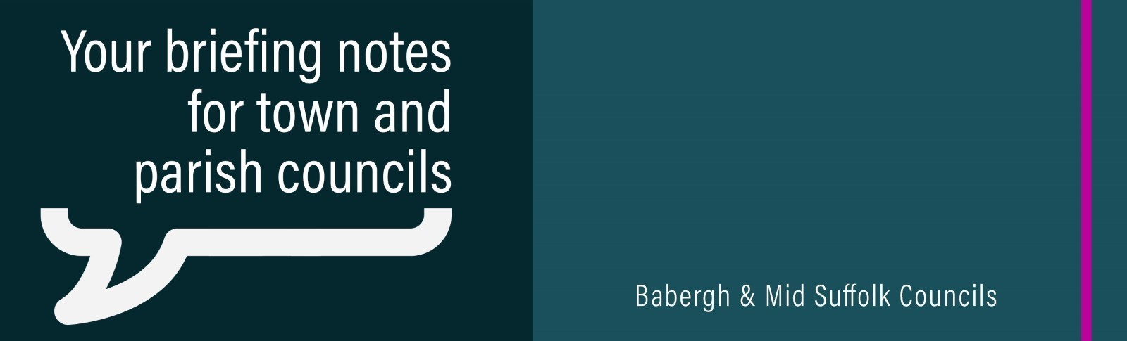
Three councils for Suffolk business case submitted to the government
Plans to transform local services were agreed this week by Suffolk’s district and borough councils, as well as cabinet members, and have been submitted to the Government.

Case for Change plans to revolutionise Suffolk council services published
Plans to revolutionise council services in Suffolk – delivering real improvements for local communities, saving at least £34m a year, and reinvesting £20m of that money annually into council services – have been published.

Grant returns to tackle winter loneliness
A grant aimed at tackling social isolation during the colder months has returned for a third consecutive year thanks to continued funding from Babergh and Mid Suffolk District Councils.

Babergh District Council partners with EEZYBIKE to launch new e-bikes in Lavenham
Residents and visitors in Lavenham can now hire EEZYBIKEs that are stored in an EEZYPOD in the Cock Inn car park, off Church Street.

Pre-school places, playgrounds and village facilities receive funding boost
Pre-school provision, playgrounds, footpaths to connect villages and village hall improvements are amongst the successful bids to receive Community Infrastructure Levy funding, following agreement by cabinet members at Babergh District Council.

Babergh and Mid Suffolk District Councils restate objections to pylon project as application submitted
Both Babergh and Mid Suffolk District Councils have objected to the “considerable and potentially devastating impacts” of National Grid’s Norwich to Tilbury project, with pylons proposed to cut through communities and countryside, including some of the districts’ most sensitive landscapes.

Communities brave the elements to show support for elite cyclists
Organisers of the Lloyds Tour of Britain thanked communities for braving the elements and turning out in force to support the race through town and villages across our districts.

32,000 solar panels and counting for Solar Together Suffolk project
The successful Solar Together Suffolk scheme is now open for registration for 2025.

Unparalleled parking in Babergh and Mid Suffolk
Babergh and Mid Suffolk District Councils have earned 19 Park Mark and Park Access awards for their work improving safety and accessibility in their car parks.

More students given opportunity to debate climate issues at COP-style event
Almost 100 year 8 and 9 students from schools across Babergh and Mid Suffolk will take part in a COP-style event next month.

VCFSE funding summits
The Babergh and Mid Suffolk grants and funding team will be hosting a free funding summit on Wednesday 19 November at Chamberlin Hall, Bildeston, from 9am to 2.30pm. The event will help community organisations access the funding they need and is being delivered in partnership with Suffolk Community Foundation, Community Action Suffolk, Suffolk County Council and the National Lottery Community Fund. Book online: Conference Booking Form : AideCRM

