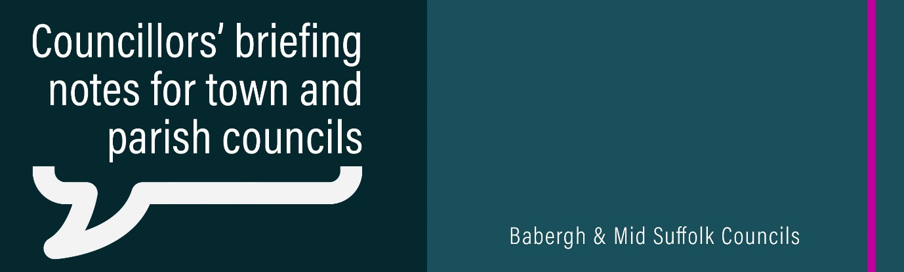

August 2023

Coalition puts climate, housing and community at heart of its priorities
Increased climate change action, close collaboration with communities, and a focus on good housing will be priorities for the new coalition at Babergh District Council. More information

Councils reiterate objections to pylon proposals
Babergh and Mid Suffolk District Councils have written to the Government restating their objections to plans for more pylons in the Suffolk countryside. More information and see the letter from Chair Cllr Elisabeth Malvisi here.

You’re not alone: Support available as more people seek cost of living help
Find out what help you are entitled to – that is the message from the district councils and Citizens Advice, as residents and families continue to deal with the high cost of living. More information

Helping residents to make their homes warmer and more energy efficient
Warm Homes Suffolk is now accepting applications to fund improvements to houses across Babergh and Mid Suffolk – making them warmer this winter and saving residents money on their energy bills. More information

Activities to support families over the summer holidays
A mixture of activities are available over the summer holidays to provide entertainment and support to families in Babergh and Mid Suffolk as part of the councils’ commitment to health and wellbeing. More information

Babergh & Mid Suffolk programme funds first business innovation projects with Essex researchers
Babergh and Mid Suffolk District Councils, in partnership with the University of Essex, have funded four business innovation projects through the unique Innovate to Elevate programme. More information

Orchestra shares the joy of live music with Babergh residents
Babergh District Council has partnered with a national charity to bring an exciting musical experience to residents. More information

Council thanks volunteer group after Pin Mill management changes
Babergh District Council has resumed management responsibility for a key part of Pin Mill, on the banks of the River Orwell. More information

Annual canvass underway

Our annual canvass of electors 2023 is underway - ensuring everyone eligble to vote across our districts can have their say in any forthcoming elections or referendums.
We are required by law to carry out an annual canvass to ensure we maintain an up-to-date electoral register, meaning we must contact every residential property within Babergh and Mid Suffolk.
We started contacting residents by email during July, with most households preferring to update or confirm their details online. Those who do not respond online will need to return paper annual canvass forms instead, to be sent out during August.
We have included information on our website, on social media, and alerted ward councillors, but would also appreciate your support in offering reassurance to residents if required. More information.
Residents’ survery
Our residents’ survey also got underway during July. We ask around 16,000 people across our districts about a range of subjects - giving us valuable insight to help up shape our future priorities and improve our services.

We ask residents for their views on subjects including the local area and facilities, public services, communities, getting around, internet access and wellbeing.

Only those residents who have received an invitation can participate, to ensure we have a representative mix of people.

- Up to three adults in each household that receives an invitation can take part.
- The first invitation letters went out on 21 July, 2023, asking people to complete the survey online.
- If it is not completed online, a follow-up paper version of the survey will be sent on 25 August, 2023.
- The consultation period ends on 1 October, with results due on 15 November.

Again, we would be grateful for your support reassuring residents and encouraging them to give their views. More information.

Elections Review
Earlier this month, chief executive and returning officer Arthur Charvonia wrote to all towns and parishes sharing the outcome of a review of issues experienced during the district, town and parish elections earlier this year.

A report by the Chief Executive of the Association of Electoral Administrators, in consultation with the Electoral Commission, and the outcome of an extended internal ‘wash up’ review of the elections were shared ahead of being published and discussed during this month’s district council meetings.

The external report confirms that the district, town and parish elections were safely and securely delivered; and that there were no inherent failings in our elections process. The review also notes the issues were resolved efficiently and effectively, and that there were many mitigating issues unlikely to arise again.

It is, however, a priority for us that everyone can have complete confidence in our election processes and we are now developing a detailed action plan to address all issues identified by this external and our own internal report. This draft action plan will be brought to our Joint Audit & Standards Committee to consider later this summer.

Hybrid meeting option for Planning Committee
We are now able to offer a hybrid meeting facility for some of our planning committee meetings – meaning public speakers, including town and parish representatives, objectors and supporters, have the option to participate in the meetings via Microsoft Teams rather than attending in person.
The hybrid option will only be available for meetings which are held in the Council Chamber, due to technology requirements. The agenda for each meeting will include details of the location for the meeting, and whether speakers are able to join virtually.
People attending virtually will do so through Microsoft Teams and will be required to inform the Committees Team at least 24 hours before the meeting that they wish to attend virtually to enable the team to put arrangements in place. Full details will be emailed to attendees joining virtually once they have registered.
Members of the Committee, presenting officers, the planning lawyer and the governance officer will still be required to attend in person to ensure that should there be any technical issues the meeting can still proceed. Should you have any queries, please contact our Committee Services team.

