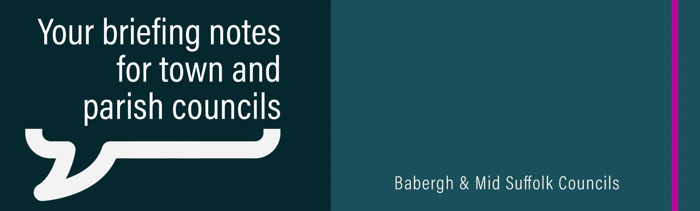
District and Borough Councils’ clear message to communities: “Let’s shape the future of Suffolk together!”
Suffolk’s five district and borough councils are launching a county-wide survey asking people for their views on the future of vital local government services. Make sure you take the survey yourself and share it with your community. We will also be sending promotional materials to each clerk and would be grateful for your support in encouraging local residents to have their say.

Newly elected leader on ambitious plans and the need for innovative successor councils
The newly elected leader of Babergh District Council says there is a ‘long and ambitious list’ for the district ahead of major changes to local councils in the next three years.

Babergh District Council’s new Chair supports domestic abuse charity
Babergh District Council’s newly-elected Chair Cllr Ruth Hendry is supporting a charity close to her heart for her fundraising this year, having revealed she experienced domestic abuse as teenager.

Response to Government feedback on Suffolk councils' plans for Local Government Reorganisation
At the start of May, the Government provided feedback to the interim proposals for Local Government Reorganisation submitted by Suffolk’s councils.

‘Ensuring respect and fairness’ - Councils restate commitment to Armed Forces Covenant
Babergh and Mid Suffolk District Councils have restated their commitment to the Armed Forces Covenant – an important pledge for thousands of families in the districts.

A message from our Chair on the 80th anniversary of VE Day
Ahead of the 80th anniversary of VE Day on Thursday, 8 May, former Chair Cllr Elisabeth Malvisi issued a message to mark the occasion.

Council partners with EEZYBIKE to launch new electric bikes in Sudbury
Two new electric bikes can now be hired in Sudbury thanks to a new partnership between the council and Suffolk-based electric bike company EEZYBIKE.

Councils pledge to continue improving services for social housing tenants
Housing teams at Babergh and Mid Suffolk District Councils have turned the tide for tenants, transforming the service they provide and promising further improvements still with the launch of their new ‘repairs pledges’.

Onwards and upwards for Babergh Chair’s chosen charities
Babergh’s outgoing Chair, Cllr Elisabeth Malvisi, has raised more than £3,800 to be shared equally between her two chosen charities.

Free tree for every Babergh and Mid Suffolk baby born in 2025
Applications for a popular free tree scheme are now open for families in Babergh and Mid Suffolk celebrating new arrivals.

Suffolk Community Awards open for nominations
Nominations for the Suffolk Community Awards 2025 are now open. The awards aim to celebrate all those that have improved the quality of life for communities across the county. Nominations can be made on the Suffolk Community Awards website.

