Glemsford Parish Council
Meeting to be held at Glemsford Village Hall Tuesday 9th December 2025 @ 7.00pm

Draft Minutes
Chair: Cllr Southgate.
In attendance: Cllr Ansell, Cllr Tunbridge, Cllr Michael Holt, Cllr Margaret Holt, Cllr Broadbent, Cllr Hall, Cllr Marks, Cllr Dotesio-Eyers, Cllr Poulton
Clerk: Mrs Julia Howard
Public: Three

25/144 Parish Announcements - none
25/145 Apologies for absence – Cllr Plumb and Cllr Kemp
25/146 Declarations of interest / dispensation requests - none
25/147 To adopt the minutes of the last Council meeting
RESOLVED all agreed by show of hands

25/148 To receive reports: County Councillor’s report (Mr Kemp) (none this month)
District Councillor’s report (Mr M Holt)
District Councillor’s report (Mr S Plumb)
Please refer to reports on the PC’s website. Cllr Holt gave a summary of key points.
Chair Southgate asked whether, in view of the Mayoral elections being postponed to 2028, the SCC elections will go ahead next year. Cllr Holt discussed this briefly and said that as it stands they will go ahead in May, although there are considerations that they may be postponed.

25/149 Public Question Time –
One resident raised concerns about the sheer weight of traffic flowing through the village. HGV’s and double decker busses, and speeding cars are a hazard. The road is becoming dangerous for pedestrians and animals alike. They would like to get behind a solution to the problem, installation of traffic calming measures etc. Suggestions included community speed watch, 20mph speed limits, give way sections etc.
Resident two, came to speak to the PC about the solar farm item on the planning section, DC/23/05127. They represent the Save Glem Valley group who has put an objection on the planning portal. There is no community benefit from the project. They asked for the PC to vote against the development.

25/150 Financial Matters
Item 1. To note receipts and approve upcoming payments
RESOLVED all agreed by nod of head
£13,194.00 – Gardens Arb Ltd
£8,986.69 – Public Works Board Loan
£700.00 – Glemsford Relief in Need Charity (Allotment site rental)
£400.00 – Christmas event spend
£78.78 – Purchase of Gazebos
Item 2. Budget Setting for 26/27 and precept request
RESOLVED all agreed with the budget proposal and precept proposal. Next steps are to sign off the precept request at the January PC meeting.

25/151 Planning
New Applications –
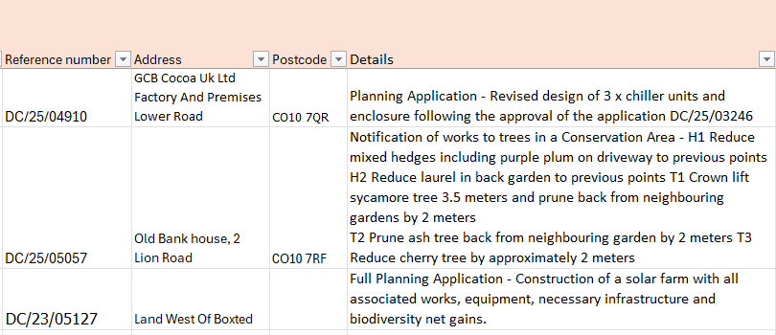
- All in favour. 2. All in favour. 3. Cllr Michael Holt abstained from voting on this, All voted to object to this application and the clerk will inform the planning department.

Decisions

25/152 Neighbourhood Plan – Robert Hobbs, head of strategic planning will visit the PC on Thursday 18th. There is a charge of approx. £6k to complete the SEA report. Cllr Michael Holt has also made enquiries around funding options.

25/141 Reports from Working Group leads where requested
1. Finance (Lesli) – all covered earlier in the PC meeting
2. Village Hall (Debbie) –
RESOLVED Purchase go-pak tables at a cost of 2466.15+vat, minus 5% discount, all in agreement by show of hands. New CCTV now on the roof for the solar panels.
RESOLVED Price to replace solar panels of £671+VAT from our routine electrician, which is approx. half the quote from the installer. The PC voted to go ahead and replace at the lower cost. All in agreement by show of hands.
3. Planning / Neighbourhood Plan (Wendy)-none
4. Public Rights of Way / Highways (Bill)- the disc on the ground that replaced a finger post has been reported but not replaced with a finger post. There have been several complaints about it.
There have been several complaints about speeding on Skates hill, in particular where there is no footpath or pavement. Bushes and trees in residents’ gardens are allowed to grow over the pavements, roads and footpaths, which narrows roads and pathways. Cllr Michael Holt has emailed SCC to ask for a survey of the road to be done, to determine whether it is fit for purpose.
5. Play Parks (Adrian)- Three quotes were received. Following discussion, Playscape was proposed to undertake the repairs.
RESOLVED by show of hands to go forward with the quote from playscape.
6. Community Engagement & Events – (Debbie /Wendy) Parish Council Christmas event is all ready to go.
7. Greening Glemsford – Cllr Tunbridge asked the Chair to allow this item to be included in the meeting even though it was not on the agenda. The WG has had a recent meeting and is thinking about adding a third litter picking event, also looking at adding a barn owl box. The wilding area at the Church has been agreed to be expanded.
25/142 Correspondence to report
Christmas tree collection from the Village Hall is on Monday 5th January which is before the 12th day (the clerk will double check on this date). The Footpath by Whitland’s and Fair Green is slippery and dangerous and is the responsibility of SCC.
25/143 Date of next Parish Council meeting: 13th January – meeting closed at 20.04

