GLEMSFORD PARISH COUNCIL Meeting @ Glemsford Village Hall, Tuesday 10th February 2026 at 7pm

DRAFT MINUTES

Chair: Cllr Southgate
In attendance: Cllr Poulton, Cllr Broadbent, Cllr Marks, Cllr Margaret Holt
Members of the public: Four

26/012 Parish Announcements – New classes at the village hall – Pilates with Poppy on a Monday morning and Glemsford spiritual development group 1st Tuesday evening of the month, both in the Heritage room
26/013 Apologies for absence – Cllr Tunbridge, Cllr Ansell, Cllr Hall, Cllr Dotesio-Eyers, Cllr Kemp, Cllr Plumb and Cllr Michael Holt
26/014 Declarations of Interest /dispensation requests – Cllr Broadbent re: Planning item
To declare any Disclosable Pecuniary or non-Pecuniary Interest relating to items on the agenda
26/015 To adopt the minutes of the last Council meeting – please see the reports on the PC’s website
26/016 To receive reports: County Councillor’s report (Mr Kemp) (none this month)
District Councillor’s report (Mr M Holt)
District Councillor’s report (Mr S Plumb)
26/017 Public Question Time
- A member of public asked for an update on the status of the Neighbourhood plan. The PC has put this on hold, awaiting more information from BDC. The PC had to withdraw the plan and will need to pay for the SEA to be updated at a cost of around £6k. There is no grant funding available at the moment and the PC hasn’t budgeted for this expenditure.

26/018 Financial Matters To note and Decision
Item 1. To note receipts and approve upcoming payments
£200 – SLCC Membership
Charge card purchases (to note)
£ 74.37 Amazon purchase, Line marking Paint, Line guide, USB Hub and carbon paper (on Chargecard)
£182.94 – Viking, toilet roll holders
£176.40 – TP Fire, replacement bulkhead light to kitchen
RESOLVED by show of hands, the PC approved upcoming payments, noted receipts and acknowledge the bank reconciliation
Item 2. Budget status update – as shared with the meeting pack, this was reviewed at the meeting.
26/019 Admin
Item 1. Confirmation of internal auditor – The PC confirmed that SALC will be the internal auditor at
the cost of approx. £419 +VAT, which is based on the PC’s income/spend in year
Item 2. Councillor Training – we are awaiting confirmation from SALC for the 16th June and hopefully
the week after, also on a Tuesday evening.
Item 3. Internal Audit review of actions – Cllr Tunbridge and the clerk have worked through the audit
report and most has been completed, the clerk will draft an Investment policy for approval at the next meeting
Item 4. Policies for review and Internal control statement
RESOLVED to accept reviewed policies as circulated, Safeguarding, Internal controls, Internet banking, Charge card and document retention policy. These were all signed by the chair. Cllr Tunbridge will check the internal control statement / policy and data on our website. An IT policy will be drafted for next month.

26/019 Planning
Applications –
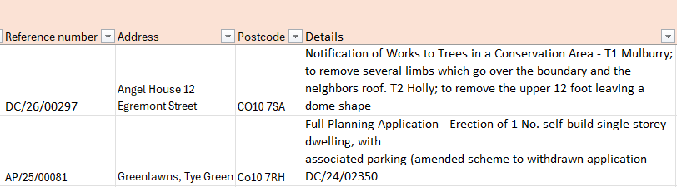
DC/26/00441 66 Tye Green, CO10 7RG Application of works to trees in a Conservation Area - G1 Reduce row of conifers back to previous pruning points approximately 4 meters to maintain the shape of the boundary hedge.
- All in favour (Cllr Broadbent abstained)
- PC are against this and holds the same view as put forward previously
- All in favour

Decisions
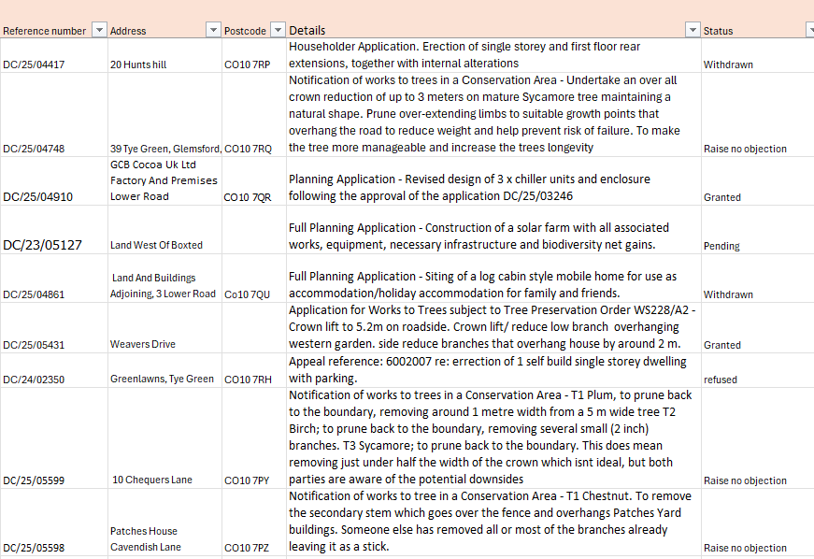

26/020 Reports from Working Group Leads, where requested
- Village Hall – toilets were blocking again, a camera investigation has been done and there isn’t any damage
there. However, there isn’t enough water going down with the toilet paper, looking at alternative options to assist with this. New toilet roll holders have been purchased and awaiting installation. 2. Allotments – the PC would like to review the contract and associated charges. Cllr Ansell is meeting the next three people on the waiting list to allocate places. 3. Events – tbc as we don’t want to clash with other village events 4. Cemeteries – the public have been asked to clear personal items so that the cemetery can be tidied and grass cut, a topple test / risk assessment is required. The PC has started reviewing and updating the charges for use of the cemetery.
26/021 Correspondence to report – New Bin / Recycling collections BDC will be sending out Pre-information packs to residents in Feb/March
BDC changes to recycling / bin collections start from June 26
26/022 Meeting Close & Date of Next meeting - next meeting is 10th March. Meeting closed at 19.32.

