GLEMSFORD PARISH COUNCIL Meeting @ Glemsford Village Hall
ON Tuesday 13th January 2026 at 7pm

Chair: Cllr Adrian Southgate
In attendance: Cllr Ansell, Cllr Poulton, Cllr Tunbridge, Cllr Marks, Cllr Hall, Cllr Michael Holt.
Public one
Clerk: Mrs Julia Howard
DRAFT Minutes

26/001 Parish Announcements - none
26/002 Apologies for absence - Cllr Dotesio-Eyers, Cllr Broadbent and Cllr Margaret Holt
26/003 Declarations of Interest /dispensation requests - none
To declare any Disclosable Pecuniary or non-Pecuniary Interest relating to items on the agenda
26/004 To adopt the minutes of the last Council meeting
RESOLVED Agreed by all as a true record, by show of hands
26/005 To receive reports: County Councillor’s report (Mr Kemp) (none this month)
District Councillor’s report (Mr M Holt)
District Councillor’s report (Mr S Plumb)
Cllr Holt gave a summary of his report, leading with an update on the Local Government reorganisation. The public consultation has now closed. Please refer to the report on the PC’s website for more information.
26/006 Public Question Time - none
26/007 Financial Matters To note and Decision
Item 1. To note receipts and approve upcoming payments as follows:
£3,345.60 – 40% deposit to Playscape for playground repairs
£110.40 – VIKING office supplies
Village Hall
£333.07 – Wave / Anglian water
£125.09 – Viking Hall supplies
And acknowledge the monthly bank reconciliation which has been passed to Cllr Tunbridge for checking
RESOLVED by show of hands, the PC approved upcoming payments, noted receipts and acknowledge the bank reconciliation
Item 2. Precept request
RESOLVED The proposal to increase the precept £127,273 which is an increase of £3,034 or 2.74% which represents a £2.59 increase to a Band D tax property taking it up to £97.23, this increase was agreed by show of hands. The precept request was then signed at the meeting.
26/008 Planning
Applications –
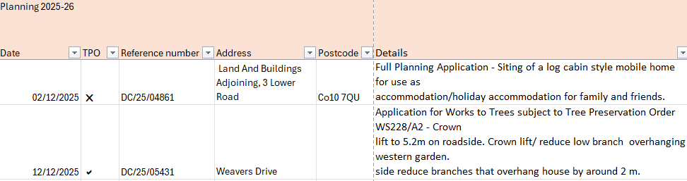

- The PC are minded to approve this however are concerned about the future use and sale of the caravan and setting a president. The PC would request that it is not used as a rental / air b&b and would like it to be obscured from road view.
This was voted on as follows: 2 for, 4 abstain, 1 object. The PC does not object to this application
- This is an application by SCC, the PC does not object to this application.
- DC/25/05598 – Patches Lane – works to trees - support
- DC/25/05599 – 10 Chequers Lane - Works to trees – support

Decisions
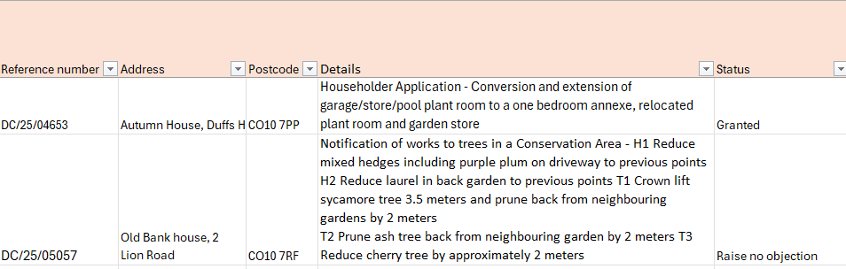

26/009 Reports from Working Group Leads, where requested
- Village Hall - The solar panels are not currently working and are due to be repaired, as agreed at the December PC meeting. Cllr Tunbridge is checking the warranty is not going to be affected by this.
Purchase of: Toilet roll holders £152.45 + VAT for 5 items to be purchased by the village hall
RESOLVED by show of hand
Toilet cisterns: these need to be changed or the flush improved to reduce costly blockages.
Fire Exit Light in Kitchen to be repaired by TP fire as instructed by the clerk following service
The old library refurbishment quotes are now in order and Cllr Tunbridge is progressing with the CIL application.
The purchase of round tables for the Heritage room will be postponed until the new financial year.
- Events – The PC and Playing Fields committee would like to do a combined summer event.
The Christmas event was a huge success, and funds raised will be used for future events. The games were really popular, the kitchen was busy with food and drink service and the craft stalls were popular. Huge thanks to Cllr Broadbent and Cllr Hall for all their efforts in putting it together.
- Highways – Cllr Kemp has liaised with SCC Highways and there will be 4 speed surveys across long Melford and leading towards Glemsford
26/010 Correspondence to report –
- Request for a Grit bin at Crownfield rd., top of estate, where the new houses are. Permission would be required from either the Property developer or BDC if it’s been handed over. The other grit bins on the estate have still got grit in which could be used in the meantime. Volunteers to spread grit in the village need to be registered with the PC to be permitted to spread the grit, please contact the PC if you’d like to volunteer.
- Water leak at Kebbles – resident has reported this to Anglian water who were due to resolve it by 15th December. They have been contacted again and gave the 16th Jan as the date it will be resolved.
- Surveyors on the field and on the access road of Old Silk Mill – the Parish Council are not aware of any developments or planning applications having been submitted for this site.
- Christmas tree festival – the Church tree festival and silver band concert raised £1447.36, £280 came from the raffle. A huge thank you to all those involved.
26/011 Meeting Close & Date of Next meeting - Meeting closed 20.23

