Glemsford Parish Council meeting held at Glemsford Village Hall Tuesday 11th November 2025 @ 7.00pm
Present: Chairman Cllr Southgate, Cllr Ansell, Cllr Tunbridge, Cllr Michael Holt, Cllr Broadbent, Cllr Marks 7 Cllr Hall
Clerk: Mrs Julia Howard
Members of the public: None
Draft Minutes
All members of the Council are hereby summonsed to attend the meeting for the purpose of considering and resolving upon the business to be transacted as set out hereunder

25/130 Parish Announcements
25/131 Apologies for absence – Cllr Poulton, Cllr Dotesio-Eyers, Cllr Plumb & Cllr Kemp
25/132 Declarations of interest / dispensation requests – Cllr Hall, Duffs Hill planning (friend non pecuniary) – will comment but abstain from voting. All re: trees at Village Hall.

25/133 To adopt the minutes of the last Council meeting
RESOLVED approved by all by show of hands.

25/134 To receive reports: County Councillor’s report (Mr Kemp) (none this month)
District Councillor’s report (Mr M Holt)
District Councillor’s report (Mr S Plumb)
Cllr Holt asked if anyone had any questions or matters to raise in relation to his report which was circulated and on the PC’s website.

25/135 Public Question Time - none

25/136 Financial Matters
Item 1. To note receipts and approve upcoming payments as circulated
Payments for Approval
£28.00 - Christmas Tree entry
£30.00 – Poppy Wreath
£66.00 – One Suffolk Hosting
£581.01 – HMRC Employers Contributions
RESOLVED It was agreed to approve the payments and receipts by show of hands

Item 2. Budget update and Bank reconciliation
The Finance working group will meet before the December meeting to bring together budgetary figures for the future year.
Cllr Holt and Cllr Plumb do still have some locality money available which the PC would like to apply for to pay for Christmas items for children of the village. The clerk will enquire.

25/137 Planning
New Applications –
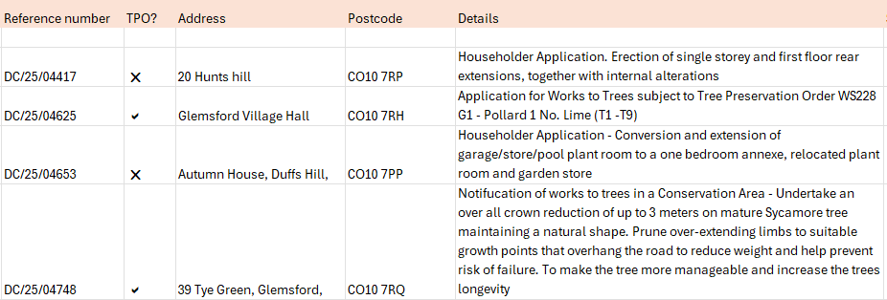

- 20 Hunts Hill – The PC objects on the grounds of over development on a heavily developed area. All agreed by show of hands
- Glemsford Village Hall trees – all abstain
- Autumn House, Duffs Hill – Cllr Hall abstains. The PC supports this, agreed by show of hands.
- 39 Tye Green – the PC typically doesn’t comment on TPO’s, Cllr Tunbridge abstained, all others objected on the basis that it would affect visual outlook in the conservation area.

Decisions
Approval: Discharge of Conditions Application for DC/22/04613 - Condition 6 (Fenestration) Location: 17 Chequers Lane, Glemsford, Sudbury, Suffolk CO10 7PW

Approval: Discharge of Conditions Application for DC/22/04532 - Condition 10 (Air Source Heat Pump), 11 (External lighting), 13 (Electric Vehicle Charging), 14 (Cycle Storage) and 17 (Biodiversity Enhancement Strategy) Location: New Street Farm, New Street, Glemsford, Sudbury Suffolk CO10 7PY

No Objection: DC/25/04312 TPO Notification of Works to Trees in a Conservation Area -T1 Apple, T2 Pear To fell to ground level. 11 Churchgate, Glemsford, Sudbury, Suffolk CO10 7QE

25/138 Neighbourhood Plan – we have received a quote of £6,628.29 +VAT to revisit the SEA report. The PC has decided to find out more details about this before proceeding.
25/139 Decision regarding the bin at Hunts Hill stores – the PC has emailed the shop owners to agree a way forward. The PC discussed this and will remove the bin on 4th December
RESOLVED
25/140 Marking of spaces in the village hall car park – The Clerk will ask Sudbury Town Council to provide a price and undertake this.
25/141 Reports from Working Group leads
1. Finance – the Unity bank account has been applied for and we are supplying additional information as requested. The Finance WG will meet next week to work through the budget.
2. Personnel - The Cleaning staff have requested annual leave over Christmas and enquired whether the hall would be closed. It was agreed that the hall won’t be officially closed, however annual leave will be permitted from 22nd December until Thursday 2nd January provided that if there was a booking and/need for cleaning to be done they would manage this.
SCRIBE finance package was discussed and in principal agreed, however the finance WG will look at how this can be funded before proceeding.
3. Village Hall – there have been requests for Wi-Fi for the hall, the clerk will look into additional Wi-Fi provision, however in the meantime if needed the clerk can provide the code.
The Finance WG will look at affordability of new tables for the heritage room and for the main hall and determine what can be purchased within the current budget and what needs to be put into the future year. The hall is short of tables as some have passed their useful life and are not repairable. Cllr Tunbridge is working on the grant application for the refurbishment of the old library.
2 solar panels have been vandalised at the weekend. The CCTV will be reviewed and additional cameras will be purchased if necessary.
RESOLVED by show of hands to install additional cameras on each side with security lights if needed.
Cllr Southgate will arrange to reinstate the lights for the car park area.
4. Cemetery– no further update.
5. Planning / Neighbourhood Plan – no further update
6. Public Rights of Way / Highways – The PC are aware that some vehicles have been parking on the grass areas which is causing damage to the ground and not ideal, but also not PC land. The Parish Council would like to apologise to anyone who has received a sign on their vehicles as this was not an approved action.
7. Greening Glemsford – has applied to the PCC to extend the wilding area, closer towards the path but not interfering with any graves. GG does annual thermal imaging camera and software surveys around the village and will have a stand at the seniors fair on 14th November. They have been approached by Hadleigh environmental action team (HEAT) and will come to Glemsford on 27th November to promote this. The next GG working group meeting will be on 3rd December.
8. Play Parks – we have had a request for a bench to be near the play park, near to the gate. We have a bench already and Cllr Tunbridge will arrange for volunteers to install the bench.
9. Allotments – Cllr Ansell has been working through the waiting list. We have added 2 new people this month and Cllr Ansell will work to allocate plots. The allotments are now well used and the waiting list is short.
10. Community Engagement & Events –Remembrance Day and Christmas event
The Christmas event on 13th December is coming along and all stalls are booked.
The Christmas tree festival at the church has the theme of ‘The Joy of Christmas’
Cllr Michael Holt left the meeting at 20.35
25/142 Correspondence to report -
- Christmas food box depot – on Tuesday 23rd December at the village hall
- Request for updated village hall risk assessment
25/143 Date of next Parish Council meeting: 9th December – meeting closed at 20.38

