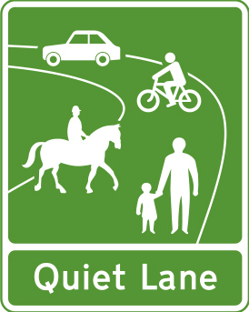

As you may know, Glemsford Parish Council is supporting the designation as a Quiet Lane of “The Horseshoe”, which comprises Shepherds Lane, Plum Street and New Street.

It has been some time since the idea of a Quiet Lane was first proposed, but at last it looks as if it could become a reality early in the new year.

The purpose of a Quiet Lane is to raise awareness of motorists that walkers, horse riders and cyclists will also be using the roadway. It does not restrict motor traffic in any way, but aims by the use of signage at either end of the Horseshoe, to alert drivers to the presence of other users.

We have finally got to the stage of Public Consultation, so if you feel you would like to comment on this proposal we will be holding a virtual Public Meeting using  Zoom on Tuesday 10th November at 18.45.

To take part please email the Parish Clerk at [clerk@glemsfordpc.co.uk](mailto:clerk@glemsfordpc.co.uk%20)   You can also use this email address for written comments.